Mapping Word Use: Network Analysis of HKSAR Government Communications across an Extended Political Crisis (2019–2020)
Kei Hou and Lesley Zhang · SoDA 501

Abstract
How does a government’s word use reorganize across an extended political crisis? This project examines HKSAR government communications from the onset of the 2019 Anti-Extradition Law Amendment Bill (Anti-ELAB) Movement through the imposition of the National Security Law in mid-2020. Instead of fixing phase boundaries by hand, we apply change-point detection to daily network metric time series to find phase boundaries from the discourse. Word co-occurrence networks are then built for each detected phase and compared across phases and across the Traditional Chinese and English parallel corpora on community structure, centralization, and lexical associations. The analysis is descriptive: we make no causal claims about intent and do not link network features to repression outcomes. The project describes how government word use reorganizes across phases, including in the post-NSL period, and how the bilingual corpora compare.

Introduction
Crises are negative events that may threaten an organization’s reputation and increase uncertainty for the public (Coombs, 2007). In media research, scholars have investigated strategies for managing these crises and evaluated their subsequent impacts. Crisis communication research treats official communications as a central site where organizations and governments respond to threats through sustained text production (Coombs, 2007). Across an extended crisis, official communications are neither random nor scripted in advance. They are shaped by the bureaucratic context and by the events as they unfold.
A substantial tradition in communication studies examines how word selection organizes meaning for audiences (Entman, 1993) and how discourse coheres into identifiable interpretive packages that evolve over time (Gamson & Modigliani, 1989). Empirical evidence further demonstrates the importance of linguistic nuance in crisis management. The use of abstract language in crisis news has been suggested to trigger high levels of attribution among the public (Borden & Zhang, 2019). Research by Guerber et al. (2020) finds that the linguistic style of an organization, such as a consultative versus formal tone, significantly influences observer perceptions. Most of this research has focused on corporations, however, leaving the communicative behaviors of governments relatively opaque. Unlike corporations, governments operate as institutional actors whose linguistic styles must balance bureaucratic legitimacy with public accountability. This study examines how governments respond to their audiences by tracking their word use over time.
This project focuses on what the government says rather than why: which words are used, which co-occur, and how the patterns reorganize across phases of a crisis. Two reasons to focus on word use rather than framing intent. Word use is directly observable in the textual record, and patterns of usage build up into structural features of the discourse.

Literature Review

Network Agenda Setting
Beyond the influence of the source, communication scholars also examine how information is delivered through various media. Agenda-setting theory (Dearing & Rogers, 1996) emphasizes media effects on the public’s perception of issue salience through a hierarchy of communication effects. This hierarchy has been explored through two primary levels: the first level focuses on the salience of objects (such as issues or candidates), and the second level examines the salience of specific attributes associated with those objects. Together, these levels explain how the media tell the audience what to think about and how to think about those subjects by emphasizing dominant characteristics. The theory also offers a strategic framework for crisis communication, including priming and framing effects (Iyengar & Simon, 1993) in crisis events.
Traditional agenda-setting models may not fully account for the complexities of modern technology, including social media. News consumption behaviors have shifted significantly over the past decades. A growing body of research shows that users increasingly rely on social media as their primary source of news (Geers, 2020; Tomasik & Matsa, 2025). While social media offers advantages such as rapid information dissemination and enhanced interpersonal communication (Aïmeur et al., 2023), its platform affordances, particularly the ability for users to create, share, and amplify content, increase the cognitive information-processing burden for the audience (Gomez Rodriguez et al., 2014), making it difficult for them to connect disparate pieces of information.
Building on this, the updated version of agenda-setting introduced a third level: Network Agenda Setting (NAS; Guo & McCombs, 2011). NAS emphasizes the network through which news media and official communications can bundle different sets of objects or attributes together, making these bundles of elements salient in the public’s mind simultaneously. When encountering crisis news events, for instance, Chinese official media accounts strictly follow government policy, while in non-crisis news these accounts tend to promote traditional culture (Wang, 2016). This study uses NAS to map the evolution of government discourse via the connections between words.

Theoretical Framework: Words, Co-occurrence, and Structure
Words do not carry meaning in isolation. As Firth (1957) put it, a word is known by the company it keeps. In corpus-based approaches, systematic patterns of co-occurrence across large bodies of text show how words are used in practice, regardless of any single speaker’s intent. For government press releases, this means the structure of word use, that is, which terms cluster together and how those clusters change over time, is what we study directly.
A network makes this structure easy to work with. Nodes are words; edges are co-occurrence ties weighted by statistical association. From there, network analysis describes the discourse at three levels: global properties such as density, centralization, and modularity describe the discourse as a whole; community detection identifies clusters of jointly used terms, similar to the discursive packages Gamson and Modigliani (1989) describe; and node-level metrics describe where individual terms sit within the structure. Recent computational work uses network-based lexical analysis for tracking political discourse over long time periods (Rule, Cointet, & Bearman, 2015; Evans & Aceves, 2016).
Across an extended crisis, the discourse will not be homogeneous. Comparing across time requires a way to split it into phases but doing so by hand risks smuggling in theoretical assumptions about when the discourse should change. We therefore use data-driven change-point detection to find phase boundaries from the discourse itself, rather than imposing them.

Hong Kong Anti-ELAB Movement
The 2019 Anti-Extradition Law Amendment Bill (Anti-ELAB) movement commenced on June 9, 2019, when approximately one million people marched against a proposal that would grant the Hong Kong government authority to extradite suspects to mainland China. The legislative initiative sought to formalize extradition arrangements with Macau, Taiwan, and Mainland China, raising widespread concerns that individuals in Hong Kong could face detention and prosecution under the mainland Chinese legal system. The remainder of 2019 was marked by persistent weekly protests, a rigid governmental stance, and reports of police misconduct and vigilante violence (Fronsina, 2021).
Compared with many contentious political events, the 2019–2020 Hong Kong Anti-ELAB movement provides an unusually rich empirical setting for examining government communication. Over the course of more than twelve months, the HKSAR government released hundreds of press statements in two parallel languages across multiple phases of the movement, including pre-suspension mobilization, policy concession, sustained contention, the onset of COVID-19 gathering restrictions, and the implementation of the National Security Law.
Existing studies have examined various dimensions of the movement, including the role of social media in mobilizing protest participation (Kow et al., 2020), public trust in the Hong Kong government (Tung et al., 2021), and public emotional responses (Liao, 2022). Few studies have examined the movement from a government communication perspective, however, particularly regarding how official actors responded to different audiences. One goal of this study is to investigate the communication structure and response patterns of the Hong Kong government during the movement.
The bilingual nature of the corpus also provides an opportunity to examine whether official narratives, framing, and linguistic patterns varied across communicative channels. Traditional Chinese primarily targeted domestic audiences, while English-language releases were directed toward international audiences and global media environments. This bilingual structure creates a natural basis for comparing how governmental discourse was adapted across audiences. The extended duration of the movement also allows for an analysis of how official discourse evolved over time rather than around a single isolated event.

Research Questions
Primary RQ. How does the semantic network structure of HKSAR government communications transform across algorithmically detected phases of the 2019–2020 discourse lifecycle, and do Chinese-language and English-language corpora exhibit parallel or divergent structural trajectories?
Sub-questions.
Where do change-point detection algorithms identify structural discontinuities in the daily network metric time series, and do Chinese and English corpora produce aligned or divergent breakpoints? What global network properties (density, modularity, centralization) characterize each detected phase? Which semantic communities (discursive packages) emerge, persist, or dissolve across phases? How do the structural positions of focal actor terms (such as protesters, police, rioters, dialogue) evolve across phases?

Data
The study draws on official press releases from the Hong Kong government’s information portal, info.gov.hk. The dataset spans June 9, 2019, the beginning of the Anti-ELAB protests, through September 2020, covering approximately sixteen months.
Relevant press releases were identified using protest-related keywords associated with the Anti-ELAB Movement in both Traditional Chinese and English. After filtering and data cleaning, the final dataset consisted of 1,864 Chinese-language statements and 1,660 English-language statements. The corpus includes communications released across multiple stages of the movement, including periods of mass protest, policy concession, COVID-19 restrictions, and the implementation of the National Security Law.
Because the Hong Kong government simultaneously communicated with domestic and international audiences, the bilingual corpus provides an opportunity to examine whether official discourse differed across linguistic channels. The Chinese and English statements were preserved as parallel corpora and analyzed independently to identify potential differences in framing strategies, linguistic structures, and patterns of governmental response.

Methodology
Preprocessing.
Chinese texts are segmented with jieba (Sun, 2012); English texts are tokenized via regular expressions with custom stopword filtering. Both corpora are filtered to retain content words and remove common boilerplate from the press-release template (font-size markers, navigation links, broadcast notices, and similar artifacts).
Daily sliding-window networks.
Daily co-occurrence networks are built using a 30-day rolling window. For each daily network, three global metrics are computed: modularity (community structure strength), density (overall connectedness), and degree centralization (concentration of associations around dominant terms). Window size is a trade-off: shorter windows give more temporal resolution but noisier networks. We report sensitivity at 15, 30, and 60 days.
Change-point detection.
Pruned Exact Linear Time (PELT) change-point detection (Killick, Fearnhead, & Eckley, 2012) is applied to each metric time series with a BIC penalty to balance fit against the number of change points. PELT is computationally efficient on long series and is a standard method for exact change-point inference. We run detection separately on Chinese and English; whether the breakpoints align across the two corpora is part of what we want to know. Change-point detection in evolving networks is an active methodological area (Peel & Clauset, 2015); we apply it to discourse networks specifically. We check robustness by running PELT at multiple penalty values and by comparing breakpoints across the three metrics.
Phase-level network construction.
For each detected phase × language pair, a sentence-level co-occurrence network is built. Edges are weighted by Positive Pointwise Mutual Information (PPMI), which corrects for raw-frequency bias by measuring co-occurrence beyond chance. Networks are implemented in NetworkX.
Community detection and tracking.
The Louvain algorithm is the primary community detection method, with Leiden (Traag, Waltman, & van Eck, 2019) applied as a robustness check given its guarantees of well-connected communities. Methodology follows Fortunato and Hric (2016); modularity evaluation follows Newman (2006). Communities are characterized by their highest-weighted internal nodes and labeled through researcher interpretation. Cross-phase community lineage is tracked via Jaccard similarity; a Sankey-style visualization traces which communities persist, merge, split, or dissolve.
Node-level analysis.
Six focal terms (示威者 / demonstrators, 警察 / police, 暴徒 / rioters, 對話 / dialogue, 市民 / citizens, 政府 / government) are tracked across phases on degree centrality, betweenness centrality, and community membership. Top-ten structural neighbors per phase give a concrete view of each focal term’s lexical neighborhood, similar in spirit to diachronic word-embedding studies (Hamilton, Leskovec, & Jurafsky, 2016) but using structural rather than distributional representations.
Cross-linguistic structural comparison.
Chinese and English trajectories are compared along three lines: correlation of the global metric series, alignment of detected breakpoints, and Jaccard overlap on top community terms (using a bilingual lexicon). The comparison is descriptive.

Analysis Plan
The analysis proceeds in seven stages. Each stage produces an intermediate output that feeds the next, so that any single parameter (window size, PPMI threshold, change-point penalty, community-detection algorithm) can be varied without re-running the full pipeline.
Stage 1. Preprocessing and corpus statistics.
Both corpora are stripped of HTML and template-induced boilerplate. Chinese statements are segmented with jieba, then filtered to retain multi-character content tokens that contain no Latin or numeric characters. English statements are tokenized via regular expressions and filtered through an extended stopword list. Per-statement token counts and sentence counts are reported as a basic descriptive layer. Statements with fewer than ten content tokens are inspected as a quality check; none are dropped from the final corpus.
Stage 2. Daily metric time series.
For each day in the observation window we take all statements from the previous thirty days and build a sentence-level co-occurrence graph, capped at the top four thousand content tokens with a minimum edge count of three. We compute density, modularity (Louvain on the largest connected component), and degree centralization for each day. The series uses a two-day stride. The stride is small enough to not affect change-point detection at the BIC penalty we use.
Stage 3. Change-point detection and phase definition.
PELT with a radial basis kernel cost is applied to each metric series, separately for Chinese and English, using a BIC-style penalty (1.5 × log(n) × σ²). We compare the detected breakpoints across metrics and across languages. Where breakpoints align across both languages, or across at least two metrics within one language, we treat them as candidate phase boundaries. The final phase definition combines this alignment table with a substantive sanity check against political events. We re-run PELT at penalty multipliers of 1.0 and 2.0 to check whether breakpoint locations are stable.
Stage 4. Phase-level networks and global properties.
For each phase × language pair, a single sentence-level co-occurrence network is built using PPMI weighting. The vocabulary is capped at the top fifteen hundred content tokens per phase, and edges are retained where the raw co-occurrence count is at least five and PPMI exceeds 1.0. Density, modularity, degree centralization, the number of communities, and the fraction of nodes in the largest connected component are reported per phase per language.
Stage 5. Community detection, labeling, and lineage.
Louvain community detection is run on the largest connected component of each phase network. Communities are labeled by the eight highest weighted-degree nodes within each community, with a substantive label assigned through interpretation. Cross-phase lineage is computed via Jaccard similarity on the top-eight terms of each community, comparing every community in phase k against every community in phase k+1. The resulting Jaccard matrices are visualized as a heatmap to show which communities persist, merge, split, or dissolve at each transition.
Stage 6. Focal-term centrality trajectories.
Six focal terms are tracked across phases: 示威者 (demonstrators) and 暴徒 (rioters or mob) as a neutral / pejorative actor-frame contrast, 對話 (dialogue) as a probe for concession-period discourse, and 警察 (police), 市民 (citizens), 政府 (government) as anchor terms. For each focal term in each phase, we record degree, weighted degree, betweenness centrality, community membership, and the top ten PPMI-weighted neighbors. Terms not in the largest connected component are noted as such; their absence from the connected core matters for our interpretation.
Stage 7. Cross-linguistic comparison.
We summarize the relationship between the two corpora in three ways. We compute Pearson and Spearman correlations between the Chinese and English metric trajectories within each phase, after aligning the daily grids. We compare the breakpoints PELT detects in each language. And we look at whether the same kinds of terms (locations, action verbs, infrastructure references) appear in both corpora’s top neighbor lists for analogous focal terms.
Robustness checks.
We plan to vary four parameters and report sensitivities: window size at 15, 30, and 60 days; PELT penalty at 1.0, 1.5, and 2.0; PPMI threshold at 0.5, 1.0, and 1.5; and Louvain versus Leiden for community detection. Findings that hold under these perturbations we treat as stable; findings that move with a particular parameter we report with the dependence.

Preliminary Results
What follows is a descriptive read of the pipeline’s output. Numbers are preliminary and reflect the methodological substitutions noted in the limitations section. We do not test hypotheses or make causal claims.

Phase boundaries from change-point detection
PELT applied independently to each daily metric series produced four breakpoints that fall on the same dates in both Chinese and English corpora: September 7–8, 2019; October 17–18, 2019; April 25, 2020; and August 2–3, 2020. The first date corresponds to Carrie Lam’s announcement of the bill’s withdrawal; the second to a period of high protest activity; the third to the period before the National Security Law took effect; and the fourth to the period just after NSL implementation. Multivariate PELT, which treats density, modularity, and centralization jointly, returned no breakpoints at any of the tested penalty levels (1.0, 1.5, 2.0). The three metrics shift on different dates rather than at the same time.
Five working phases are defined from these breakpoints: P1 (pre-concession, June 9 to September 7, 2019); P2 (post-concession, September 8 to November 15, 2019); P3 (winter and early COVID, November 16, 2019 to April 24, 2020); P4 (NSL approach, April 25 to August 1, 2020); and P5 (post-NSL, August 2 to September 30, 2020). Statement counts range from 391 to 535 in Chinese and 336 to 501 in English across the first four phases; P5 is shorter by design (145 Chinese, 128 English).
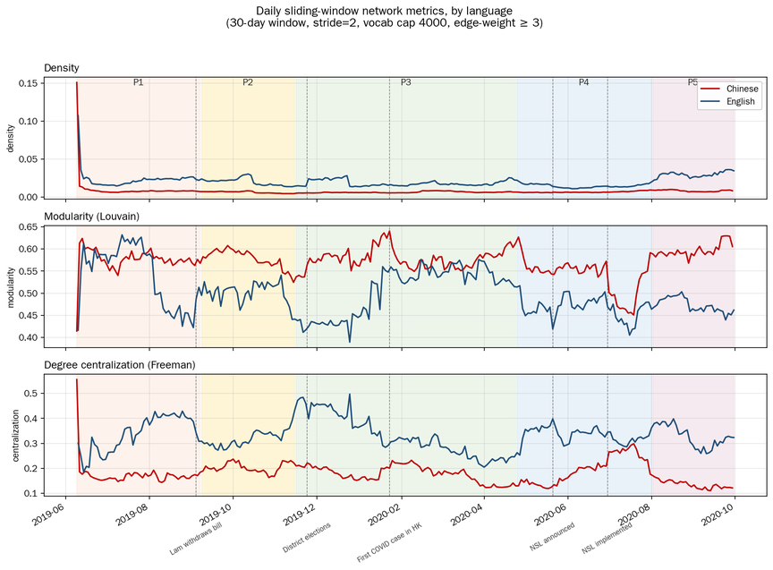
Figure 1. Daily sliding-window network metrics, Chinese versus English, with phase shading and key dates. The three panels show density, modularity, and degree centralization for the 30-day rolling networks. Vertical dashed lines mark substantive events; phase boundaries are derived from PELT change-point detection.

Global network properties by phase
Chinese modularity stays in a narrow band of roughly 0.55 to 0.60 across P1 through P4, then rises to about 0.62 in P5. English modularity starts higher in P1 (around 0.60), drops sharply during P2, settles near 0.45 from P3 onward, and stays at that level through P5. The two corpora diverge in P5: Chinese modularity rises while English modularity stays low. English density rises gradually across phases, from around 0.020 in P1 to roughly 0.035 in P5. Chinese density stays roughly flat at around 0.008 throughout.

Community structure
Louvain community detection identifies between thirteen and twenty communities per phase per language. Some of the larger communities map onto recognizable topics. In P1 Chinese, one cluster contains procedural and locational terms (道路 / road, 示威 / demonstration, 證後 / afterwards, 造成 / cause, 公路 / public road), reflecting the high frequency of traffic and public-order reports during the early protest period. In P2, an actor-action cluster forms around 暴徒 (rioters / mob) with neighbors including 圍毆 (gang-beating), 硬物 (hard objects), 布袋 (sandbags), 極端 (extreme), and 出勤 (on duty); this cluster is not present in P1. In P3, two distinct COVID-related clusters appear in Chinese, one focused on infection and prevention (感染 / infection, 病毒 / virus, 疫情 / pandemic, 措施 / measures) and one on financial relief (支援 / support, 計劃 / program, 基金 / fund, 資助 / subsidy, 申請 / application). In P4 and P5, an NSL-legislation cluster appears (行政區維護 / safeguarding administrative region, 特別 / special, 維護國家 / safeguarding the nation, 人大 / National People’s Congress).
Cross-phase Jaccard similarity on top community terms shows selective persistence. The Chinese protest-violence cluster (P2 onward) maintains Jaccard of approximately 0.4–0.5 with successors in P3 and P4. The COVID cluster appears as a new community in P3, with Jaccard near zero against any P1 or P2 cluster, and then persists with Jaccard of approximately 0.5–0.6 across P3, P4, and P5. The NSL legislation cluster appears in P4 and continues into P5. Other communities show low Jaccard across phase transitions.

Focal-term centrality across phases
We track six focal terms across phases. The largest movement is in the contrast between the neutral and pejorative terms for protesters. In Chinese, 示威者 (demonstrators, neutral) has degree centrality of 114 in P1 and falls to 91 in P2, 15 in P3, 13 in P4, and is absent from the largest connected component in P5. 暴徒 (rioters or mob, pejorative), in contrast, has degree of 2 in P1, rises to 84 in P2, then declines to 47 in P3, 28 in P4, and absent in P5. The same direction holds in English: protestors falls from 144 in P1 to 96, 25, 47, and 7 across P2 through P5; rioters is absent from the LCC in P1, appears at 85 in P2, holds at 82 in P3, falls to 51 in P4, and is absent in P5.
The dialogue term has a tighter window. 對話 (dialogue) in Chinese and dialogue in English are in the largest connected component only in P2, with degree of 6 and 7 respectively. In Chinese the term co-occurs with 深度 (deep), 直接 (direct), 平台 (platform), 社區 (community), and 不同 (different). In English the equivalent neighbors are platform, society, session, executive, and community. The term is absent from connected discourse in all other phases.
The remaining three focal terms (警察 / police, 市民 / citizens, 政府 / government) show their own patterns. In Chinese, 警察 peaks in P3 at degree 133, the highest value of any focal term in any phase, and falls sharply to 30 in P5; 政府 follows a similar arc, peaking in P3 around 95 and staying elevated through P4. 市民 stays in a narrow band across phases (degree between roughly 53 and 88). In English, police drops out of the largest connected component in P3, then recovers in P4 (degree 65) and P5 (52); citizens drops out in both P3 and P5; government peaks in P2 around 96 and is absent from the largest connected component in P5. The peak of police and government in P3 Chinese aligns with the late-protest and early-COVID period.
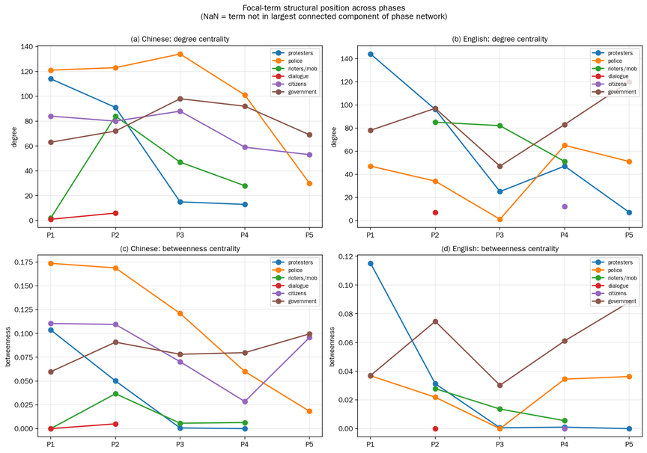
Figure 2. Focal-term structural position across phases. Top panels show degree centrality, bottom panels show betweenness centrality, in Chinese (left) and English (right). NaN indicates that the term is not present in the largest connected component of the phase network.

Network structure around the protest-related focal terms
Figure 3 displays the induced subgraph around the three protest-related focal terms (示威者 / demonstrators, 暴徒 / rioters, 對話 / dialogue) and their top-twelve PPMI neighbors in each phase of the Chinese corpus. In P1, 示威者 sits at the center of a small cluster with operational neighbors (警告 / warning, 違法行 / illegal act, 使用暴力 / use of violence); 暴徒 has only two neighbors (行為 / behavior, 暴力 / violence), and 對話 has a single neighbor (市民 / citizens). In P2, 暴徒 has more neighbors describing violence-related terms, and a set of bridge nodes (聚集 / gathering, 電台 / radio station, 大批 / large group, 警告 / warning, 強烈 / strong) connects 暴徒 to 示威者; the two terms share part of their broadcast-template neighborhood. 對話 occupies a separate connected component with its own consultative cluster. In P3, 對話 has dropped out, and 暴徒 is connected to terms describing specific tactics and locations (蒙面 / masked, 襲擊 / attack, 汽油 / petrol, 旺角 / Mong Kok, 彌敦道 / Nathan Road). In P5, none of the three focal terms are in the largest connected component.
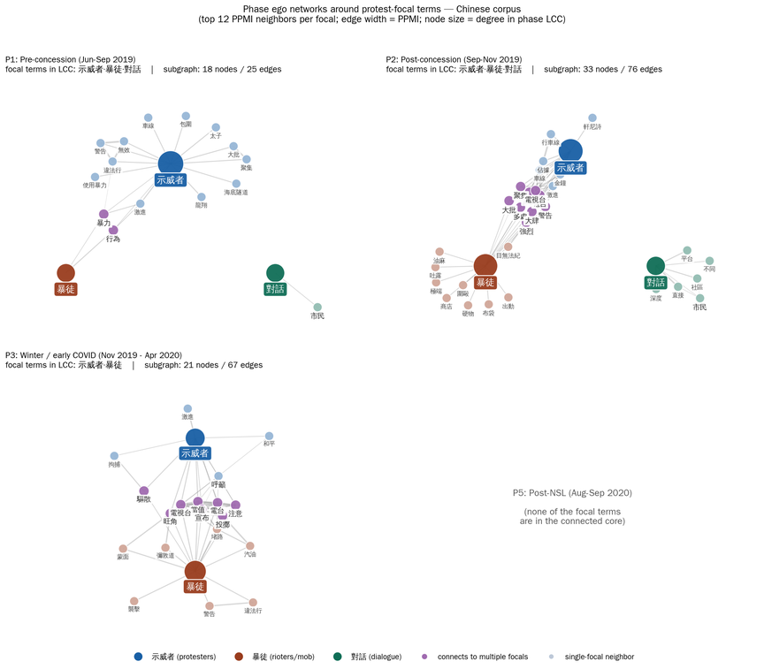
Figure 3. Phase ego networks around protest-focal terms in the Chinese corpus. Each panel shows the induced subgraph on three focal terms (示威者 / protesters, 暴徒 / rioters, 對話 / dialogue) and their top-twelve PPMI neighbors per phase. Node size scales with degree in the phase network; edge width scales with PPMI; purple nodes connect to multiple focal terms.

Cross-linguistic alignment
Pearson correlation between the daily metric trajectories of the two corpora, computed within each phase, varies across metrics and phases. Density correlation is high in P1 and P2 (r = 0.84 and 0.89), drops to 0.10 in P3, and is moderate in P4 and P5 (r = 0.34 and 0.39). Modularity correlation is moderate in P1 through P3, peaks at 0.70 in P4, and is negative in P5 (r = −0.50): in this phase, Chinese modularity rises while English modularity falls. Centralization correlation is weak in P1 and P2, moderate in P3, negative in P4 (−0.48), and strongly positive in P5 (0.84).
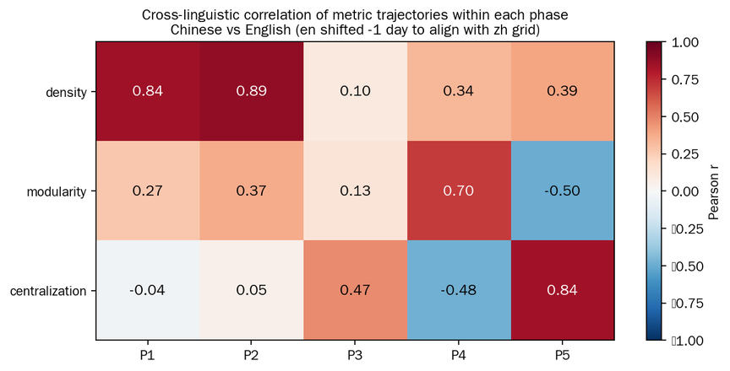
Figure 4. Cross-linguistic correlation of metric trajectories within each phase. Pearson r between Chinese and English daily metric series, computed after aligning the two daily grids. Red indicates positive correlation (parallel evolution), blue indicates negative correlation (divergent evolution).

Discussion
A few patterns stand out. PELT applied separately to each metric series, in each language, picks out four breakpoints on dates with known political content: concession, peak protest, NSL approach, and NSL implementation. Both corpora produce the same dates. The neutral and pejorative actor terms move in opposite directions in both corpora, with the pejorative term going from near-absent in P1 to high centrality in P2. The dialogue term is in the connected core only in P2.
The data-driven phasing is a methodological alternative to fixing phases by hand; it does not claim discourse alone drives political timing. The bilingual comparison asks whether the two corpora have similar or different structural shapes per phase, and that is what the cross-linguistic numbers describe.

Limitations
The preliminary analysis takes a few shortcuts that should be noted. Chinese segmentation uses jieba’s default tokenizer rather than its POS variant; we filter for content words by token length, character set, and stopword. English tokenization uses regular expressions and a hand-rolled stopword list, not spaCy with POS tagging. Some broadcast-template boilerplate (“announcers,” “intervals,” “repeat”) survives the filter and forms its own community in early English phases. Daily metrics are computed every two days rather than every day, which is fine for change-point detection at our penalty but reduces temporal resolution. Bilingual community Jaccard, which would need a Chinese-English lexicon mapping such as CEDICT, is not computed here. Multivariate PELT returned no breakpoints at any tested penalty, so we report per-metric output.

Expected Contribution and Scope
Methodologically, the project pairs change-point detection on discourse-network time series with phase-level structural network analysis. These two techniques are rarely used together in political communications work. Substantively, it describes HKSAR communications across the Anti-ELAB movement, including the post-NSL period, which has received less systematic text-analytic attention. The study is descriptive and structural; it makes no causal claims about strategic intent and does not link network features to repression outcomes. Co-occurrence captures surface lexical structure, not deeper semantic meaning. Segmentation, window size, PPMI thresholds, and change-point penalty parameters all introduce sensitivities that are explicitly reported.

References
Aïmeur, E., Amri, S., & Brassard, G. (2023). Fake news, disinformation and misinformation in social media: A review. Social Network Analysis and Mining, 13(1), 30. https://doi.org/10.1007/s13278-023-01028-5
Borden, J., & Zhang, X. A. (2019). Linguistic crisis prediction: An integration of the linguistic category model in crisis communication. Journal of Language and Social Psychology, 38(5–6), 650–679. https://doi.org/10.1177/0261927X19860870
Coombs, W. T. (2007). Protecting organization reputations during a crisis: The development and application of situational crisis communication theory. Corporate Reputation Review, 10(3), 163–176.
Dearing, J. W., & Rogers, E. M. (1996). Agenda-setting (Vol. 6). Sage.
Entman, R. M. (1993). Framing: Toward clarification of a fractured paradigm. Journal of Communication, 43(4), 51–58.
Evans, J. A., & Aceves, P. (2016). Machine translation: Mining text for social theory. Annual Review of Sociology, 42, 21–50.
Firth, J. R. (1957). A synopsis of linguistic theory, 1930–1955. In Studies in Linguistic Analysis (pp. 1–32). Blackwell.
Fortunato, S., & Hric, D. (2016). Community detection in networks: A user guide. Physics Reports, 659, 1–44.
Fronsina, S. (2021, June 8). Digital revolution: How social media shaped the 2019 Hong Kong protest. ISPI. https://www.ispionline.it/en/publication/digital-revolution-how-social-media-shaped-2019-hong-kong-protests-30756
Gamson, W. A., & Modigliani, A. (1989). Media discourse and public opinion on nuclear power: A constructionist approach. American Journal of Sociology, 95(1), 1–37.
Geers, S. (2020). News consumption across media platforms and content. Public Opinion Quarterly, 84(S1), 332–354. https://doi.org/10.1093/poq/nfaa010
Gomez Rodriguez, M., Gummadi, K., & Schoelkopf, B. (2014). Quantifying information overload in social media and its impact on social contagions. Proceedings of the International AAAI Conference on Web and Social Media, 8(1), 170–179. https://doi.org/10.1609/icwsm.v8i1.14549
Guerber, A. J., Anand, V., Ellstrand, A. E., Waller, M. A., & Reychav, I. (2020). Extending the situational crisis communication theory: The impact of linguistic style and culture. Corporate Reputation Review, 23(2), 106–127. https://doi.org/10.1057/s41299-019-00081-1
Guo, L., & McCombs, M. (2011, May). Network agenda setting: A third level of media effects. Annual Conference of the International Communication Association, Boston, MA.
Hamilton, W. L., Leskovec, J., & Jurafsky, D. (2016). Diachronic word embeddings reveal statistical laws of semantic change. In Proceedings of the 54th Annual Meeting of the Association for Computational Linguistics (pp. 1489–1501).
Iyengar, S., & Simon, A. (1993). News coverage of the Gulf crisis and public opinion: A study of agenda-setting, priming, and framing. Communication Research, 20(3), 365–383. https://doi.org/10.1177/009365093020003002
Killick, R., Fearnhead, P., & Eckley, I. A. (2012). Optimal detection of changepoints with a linear computational cost. Journal of the American Statistical Association, 107(500), 1590–1598.
Kow, Y. M., Nardi, B., & Cheng, W. K. (2020). Be water: Technologies in the leaderless anti-ELAB movement in Hong Kong. Proceedings of the 2020 CHI Conference on Human Factors in Computing Systems, 1–12. https://doi.org/10.1145/3313831.3376634
Liao, S. (2022). Feeling the 2019 Hong Kong anti-ELAB movement: Emotion and affect on the Lennon Walls. Chinese Journal of Communication, 15(3), 355–377. https://doi.org/10.1080/17544750.2021.1954964
Newman, M. E. J. (2006). Modularity and community structure in networks. Proceedings of the National Academy of Sciences, 103(23), 8577–8582.
Peel, L., & Clauset, A. (2015). Detecting change points in the large-scale structure of evolving networks. Proceedings of the 29th AAAI Conference on Artificial Intelligence, 2914–2920.
Rule, A., Cointet, J.-P., & Bearman, P. S. (2015). Lexical shifts, substantive changes, and continuity in State of the Union discourse, 1790–2014. Proceedings of the National Academy of Sciences, 112(35), 10837–10844.
Sun, J. (2012). jieba: Chinese text segmentation. Python Package. https://github.com/fxsjy/jieba
Tomasik, E., & Matsa, K. E. (2025, September 25). 1 in 5 Americans regularly get news on TikTok, up sharply from 2020. Pew Research Center. https://www.pewresearch.org/short-reads/2025/09/25/1-in-5-americans-now-regularly-get-news-on-tiktok-up-sharply-from-2020/
Traag, V. A., Waltman, L., & van Eck, N. J. (2019). From Louvain to Leiden: Guaranteeing well-connected communities. Scientific Reports, 9(1), 5233.
Tung, H. H., Lin, M.-J., & Lin, Y.-F. (2021). Anti-ELAB movement, national security law, and heterogeneous institutional trust in Hong Kong. Japanese Journal of Political Science, 22(4), 287–311. https://doi.org/10.1017/S1468109921000293
Wang, Q. (2016). A comparative case study: Network agenda setting in crisis and non-crisis news. Global Media and China, 1(3), 208–233. https://doi.org/10.1177/2059436416668870

All data and codes uploaded to https://github.com/lesleyzhanggg/soda501/tree/main/Final%20Project

